WEEK 12 / Food for thought …

1 | 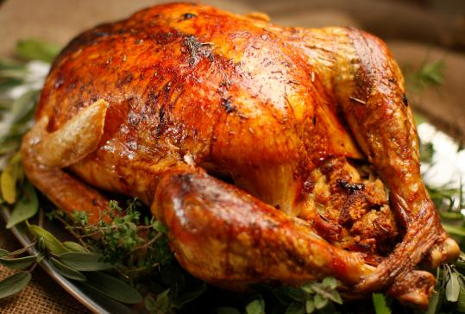 | 2 | 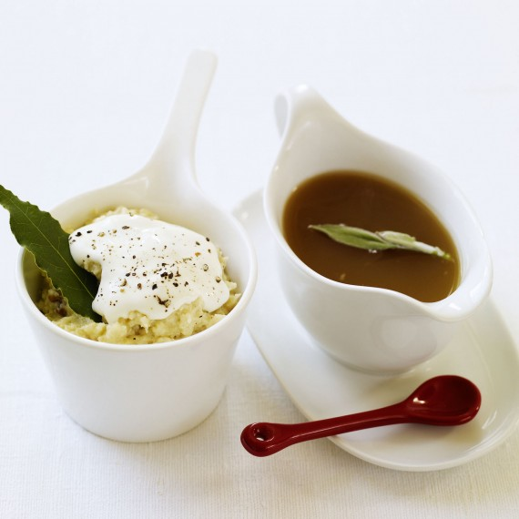 | Here are some dishes you can find on a traditional English Christmas dinner table...  Can you find their names  in English and explain  what they are in French?  Merry Christmas to one and all !!!
2 | 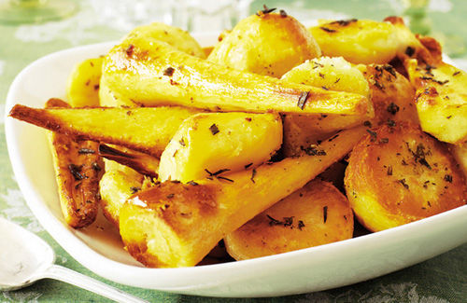 | 3 | 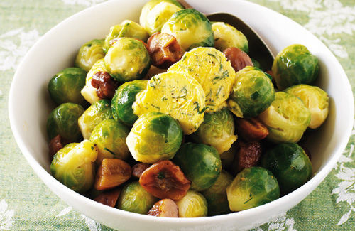
4 | 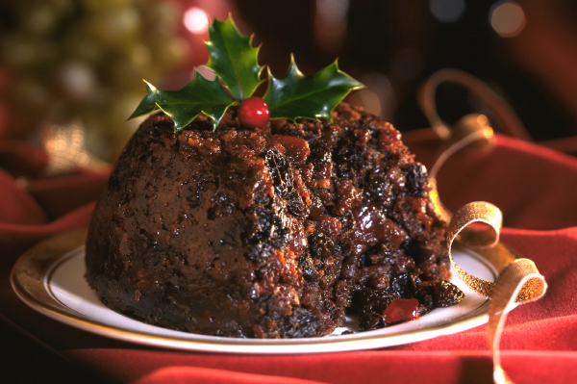 | 5 | 

