WEEK 5 / Famous landmarks

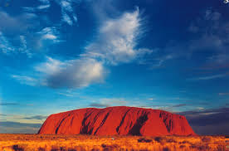 | This is one of the UNESCO World Heritage Sites.  What are its two names?  Where can you see it (country + state) ?  How high is it?


